Food Order App - NoSQL Database Design, Insert and Retrieval

Tasks 1

- Screenshot for users collection

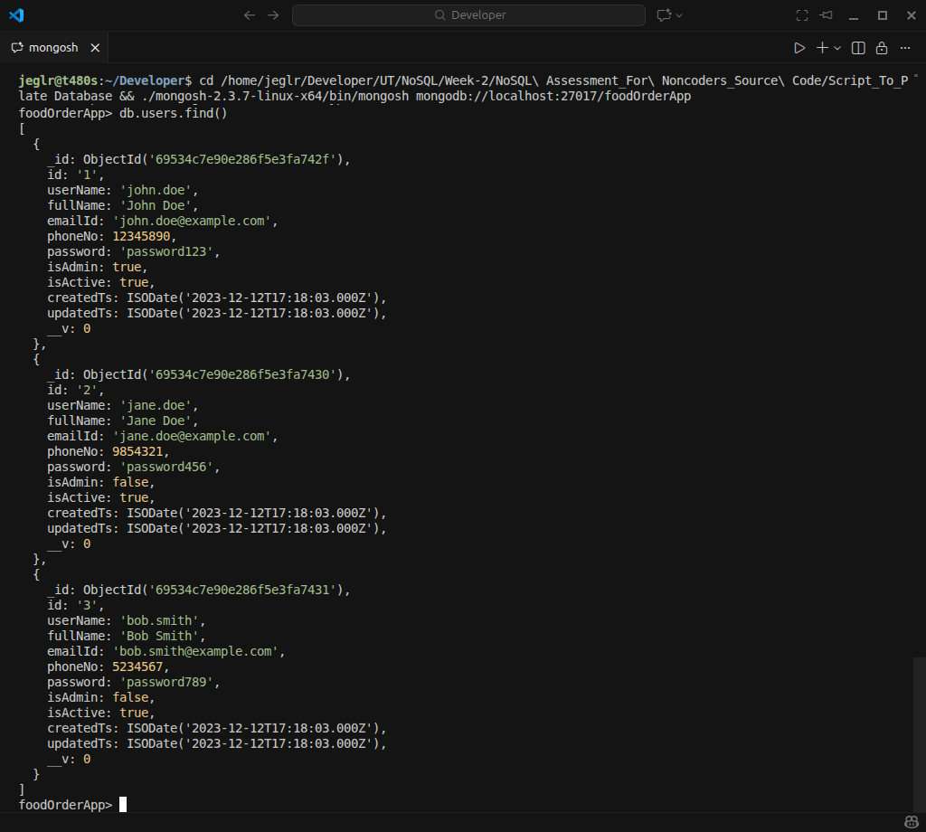

- Screenshot for userSessions collection

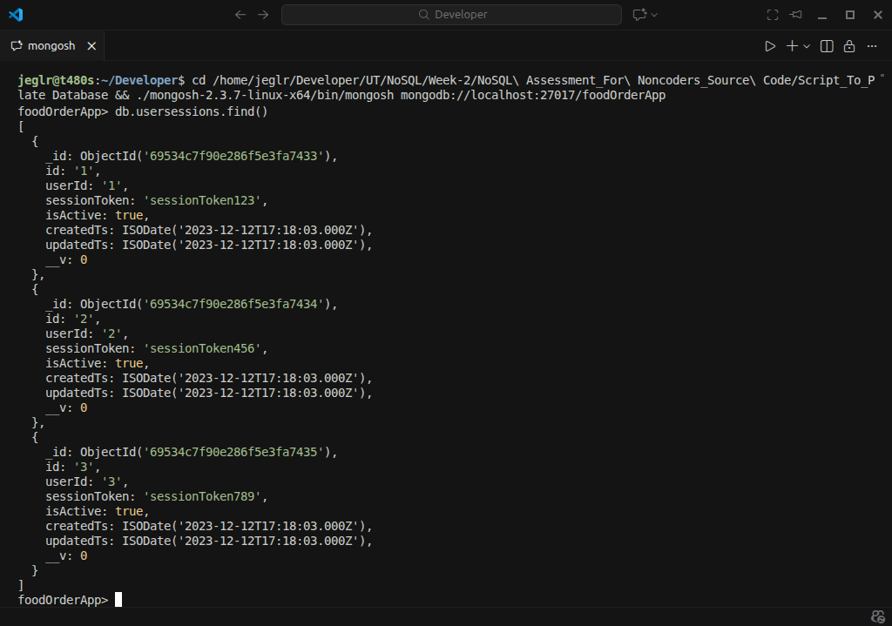

- Screenshot for categories collection
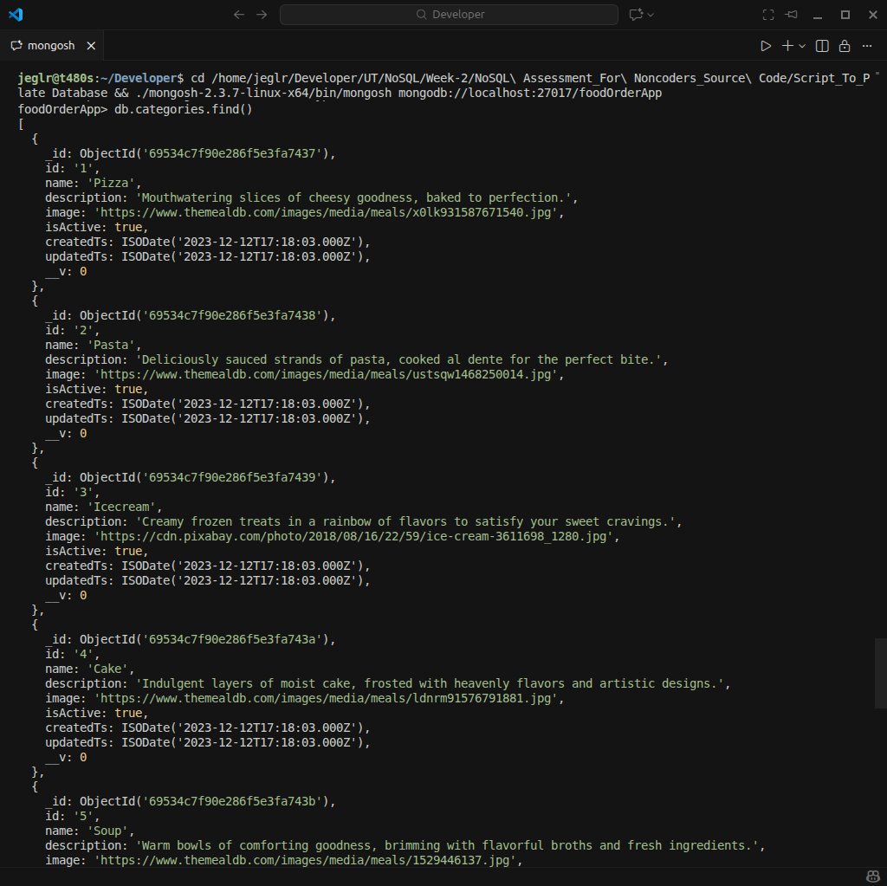

- Screenshot for cuisines collection

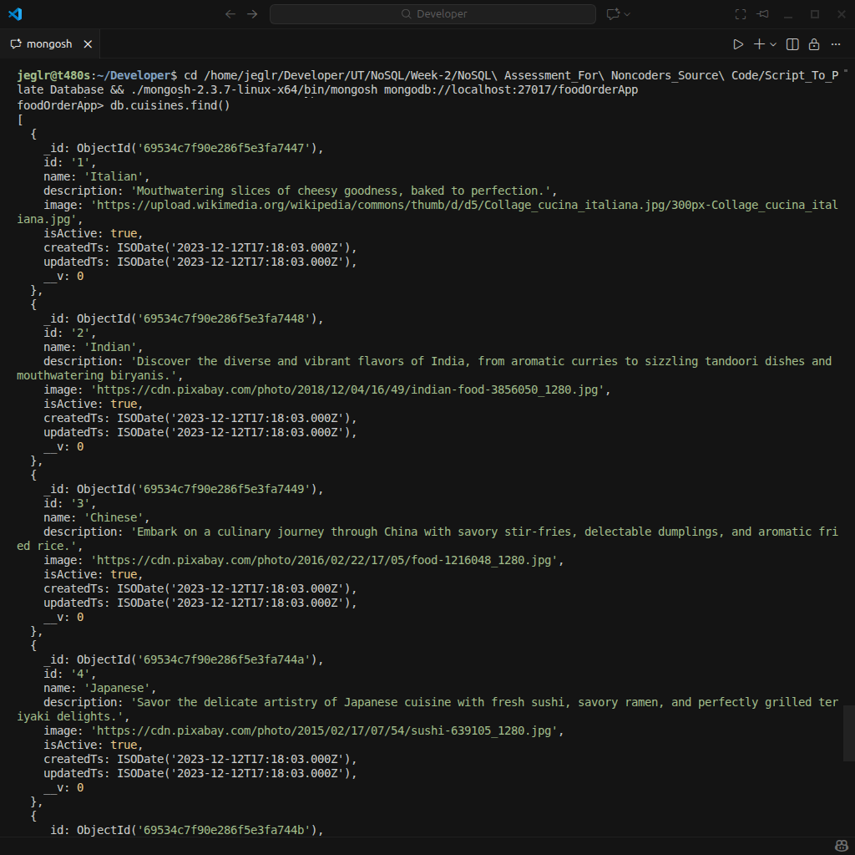

- Screenshot for restaurants collection

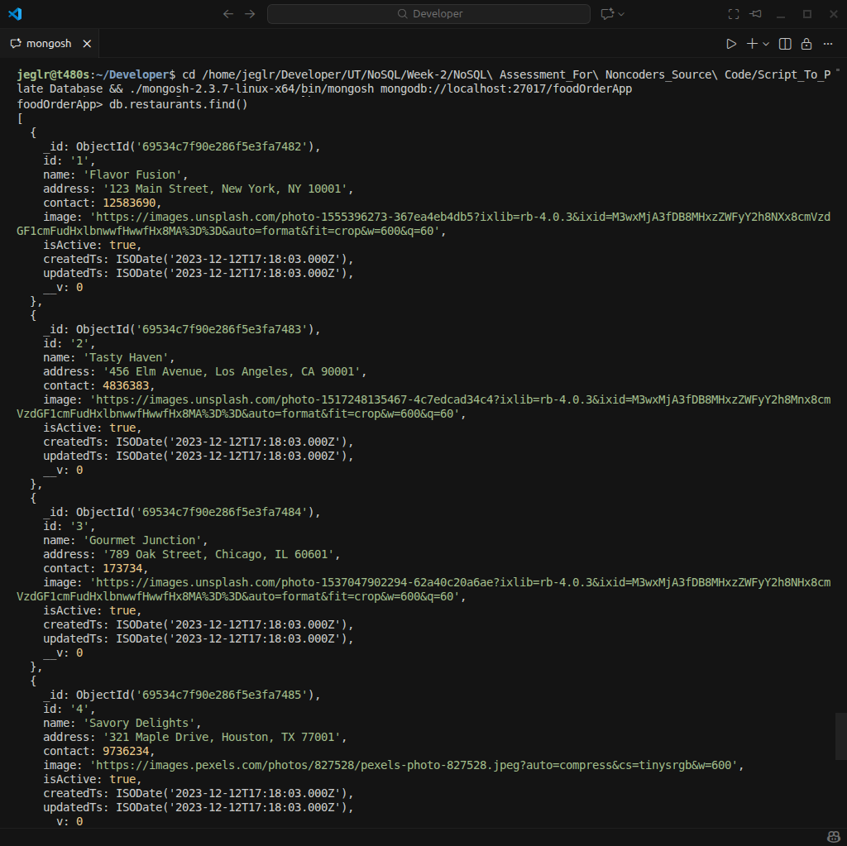

- Screenshot for fooditems collection

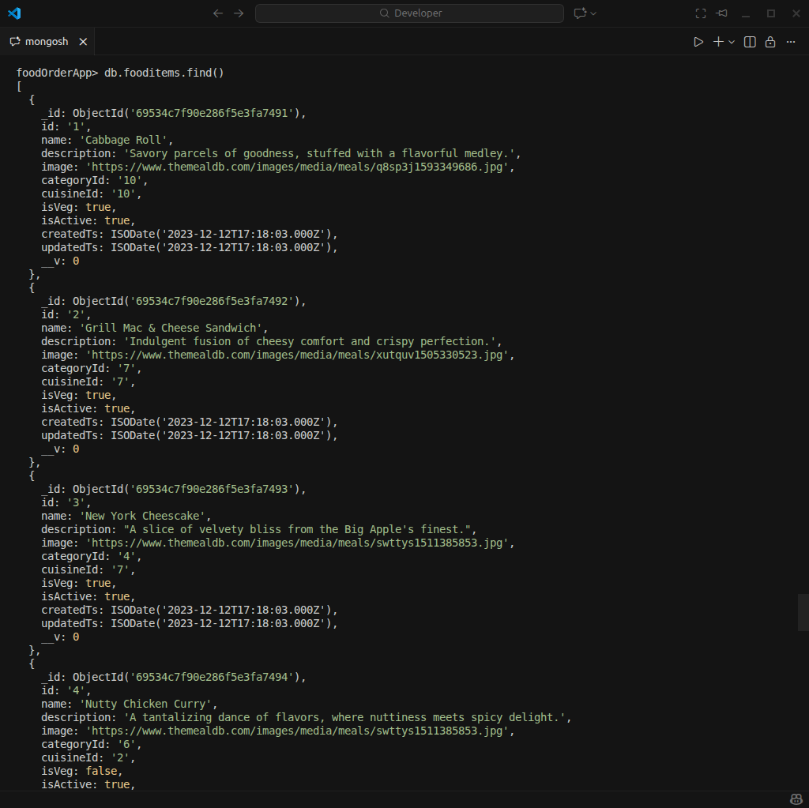

- Screenshot for menus collection

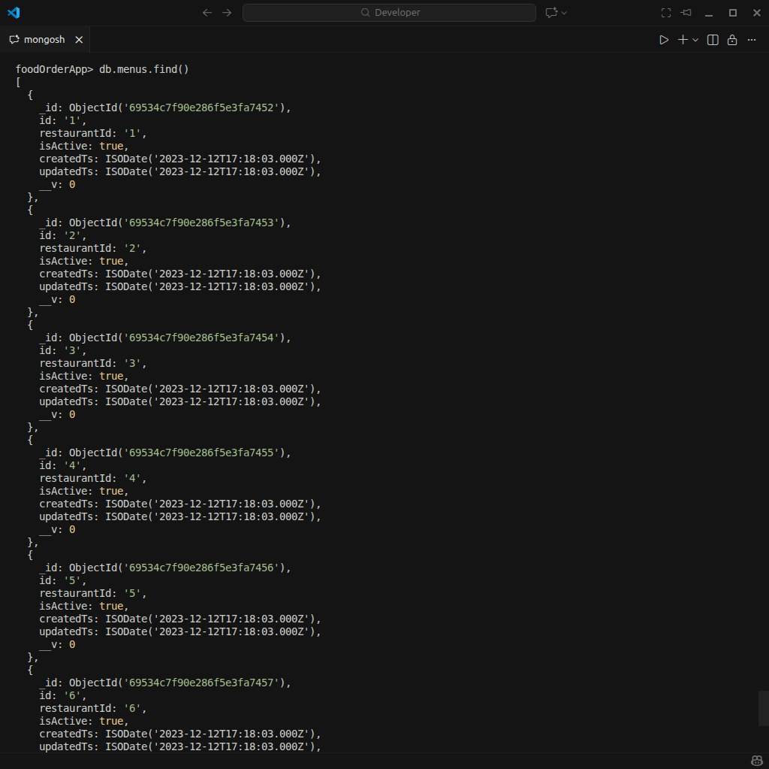

- Screenshot for menuItems collection

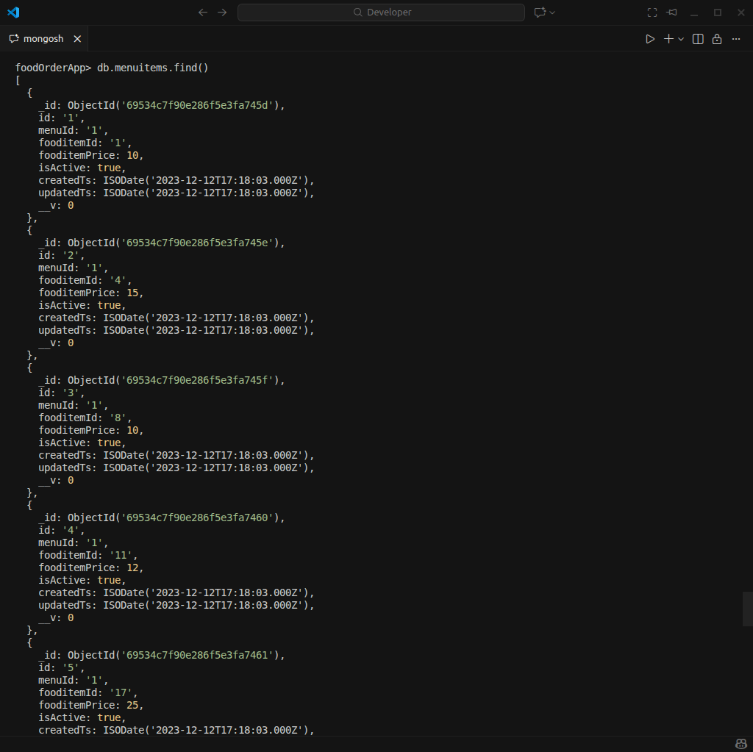

- Screenshot for carts collections

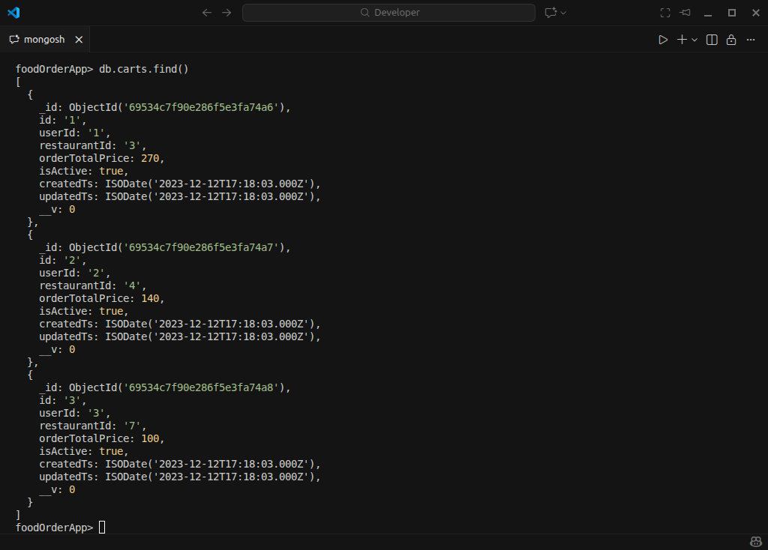

- Screenshot for cartItems collection

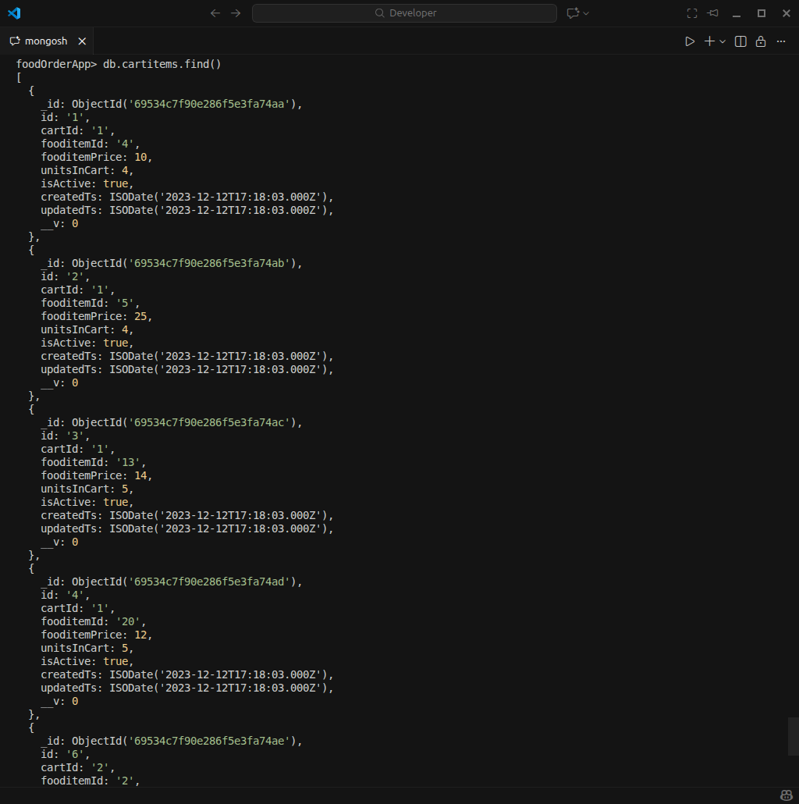

- Screenshot for shippingDetails collection

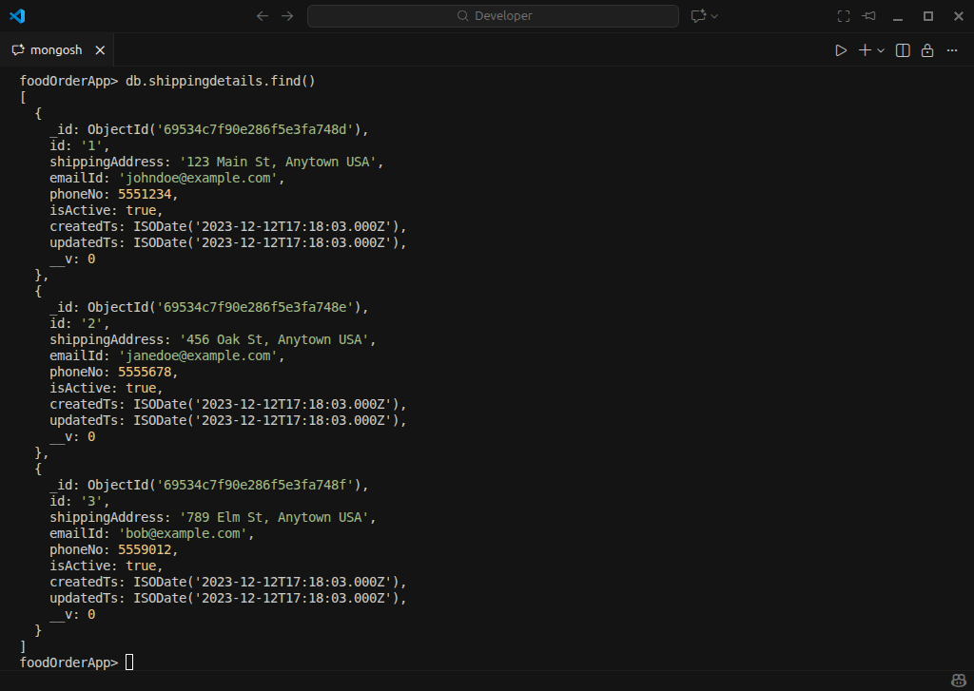

- Screenshot for orders collection

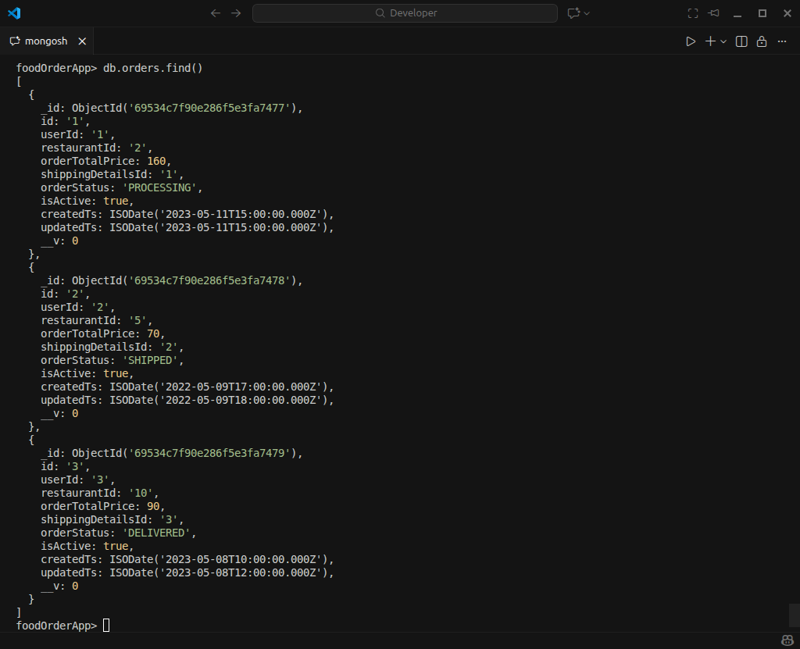

- Screenshot for orderItems collection

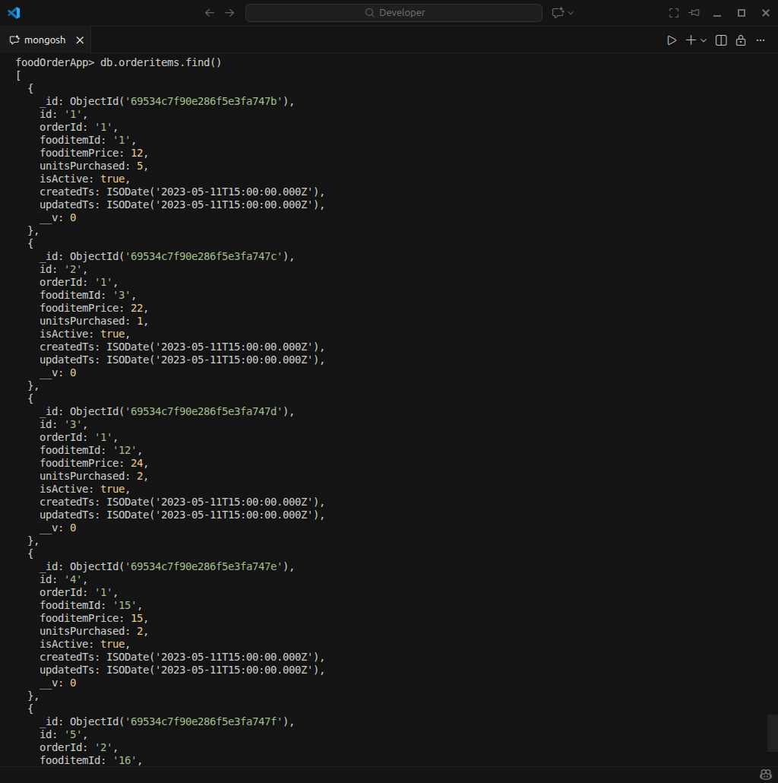

Task 2
- All distinct category names

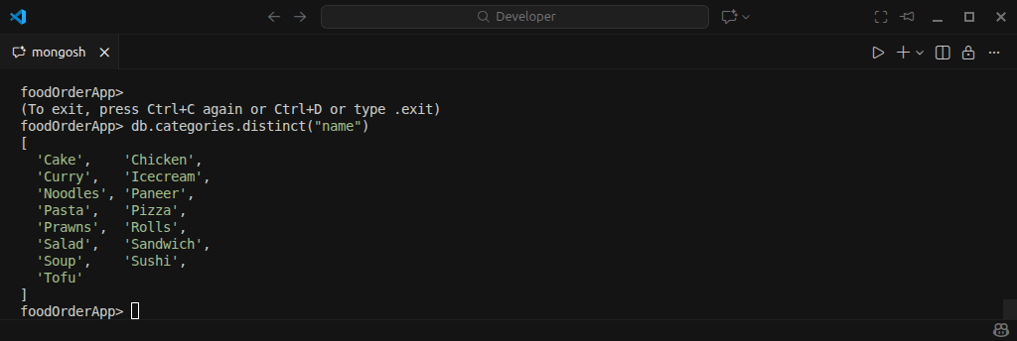

- All vegetarian fooditems

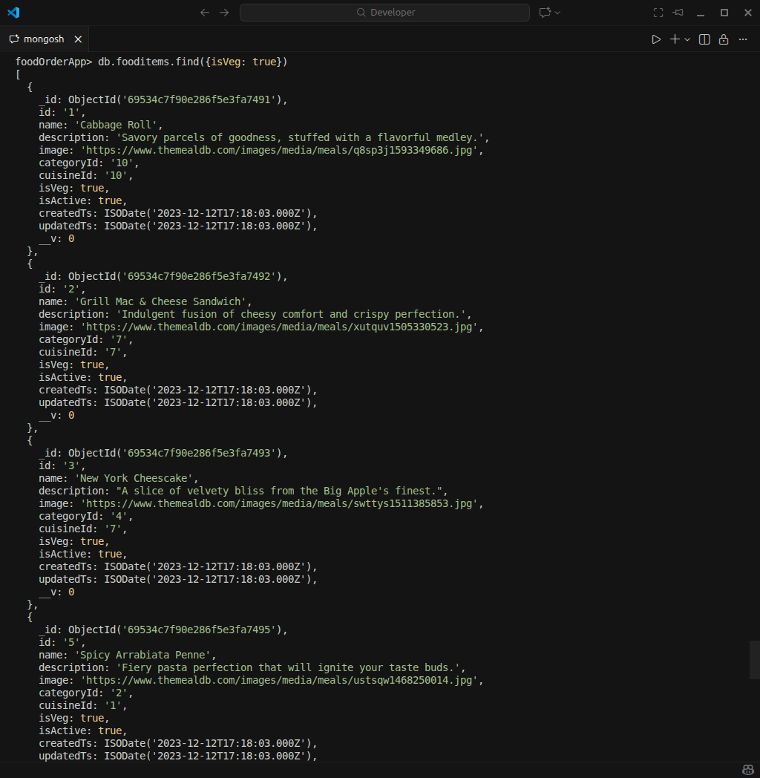

- Retrieve the name and address of each of the restaurants.

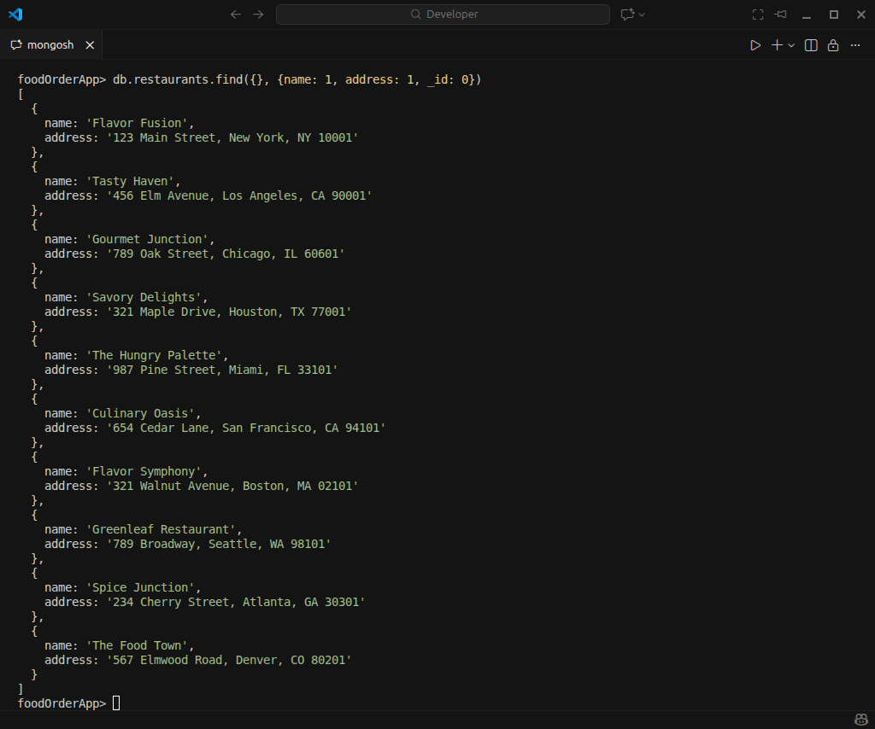

- All orders with orderTotalPrice within the range of $75 to $150.

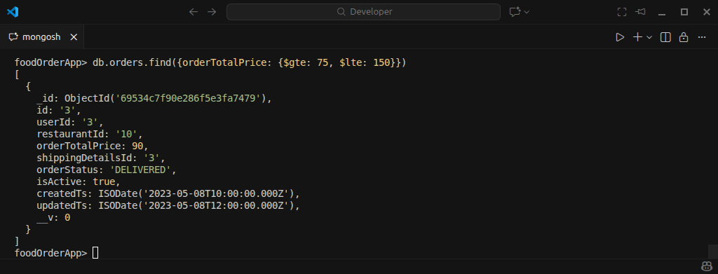

- All orders which were created after 10th May 2023.

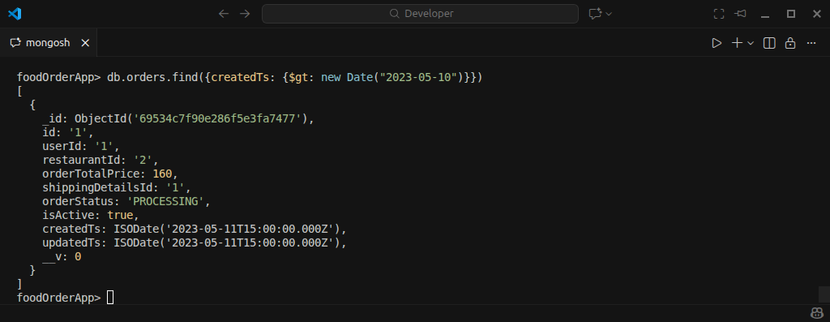

- All fooditems belonging to Italian cuisine.

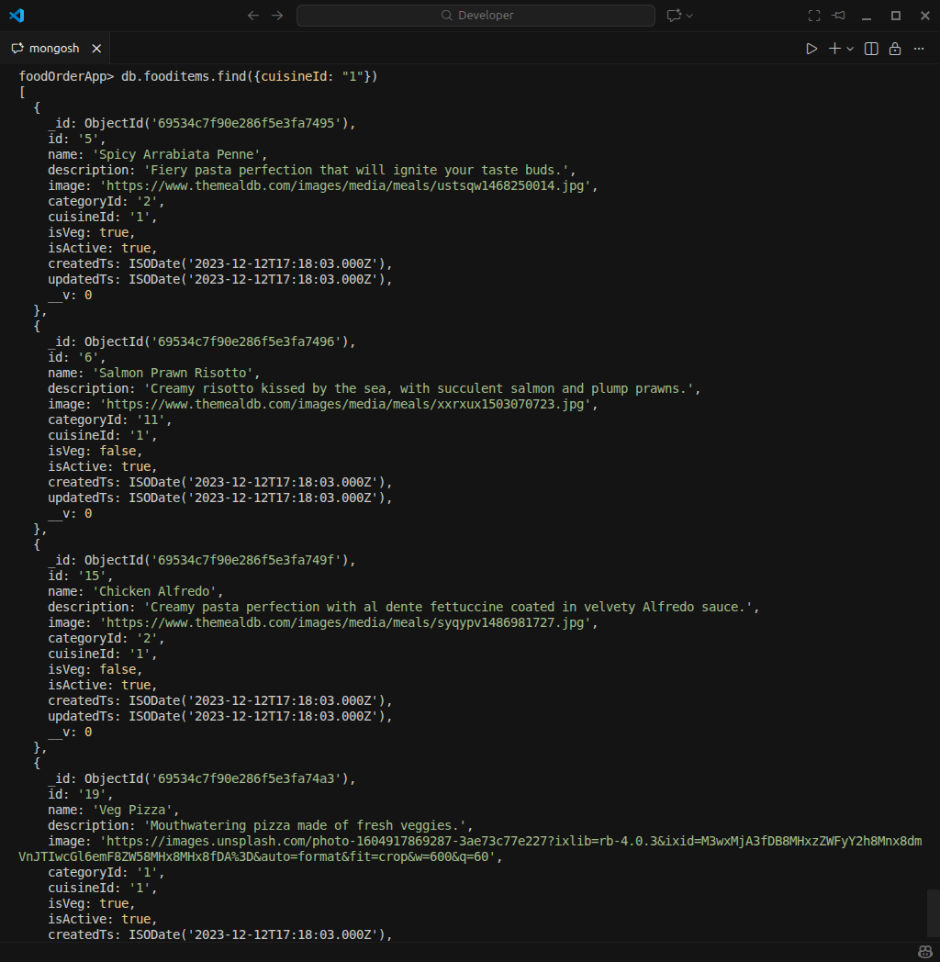

- Get the userName and email of the user with fullname "John Doe".

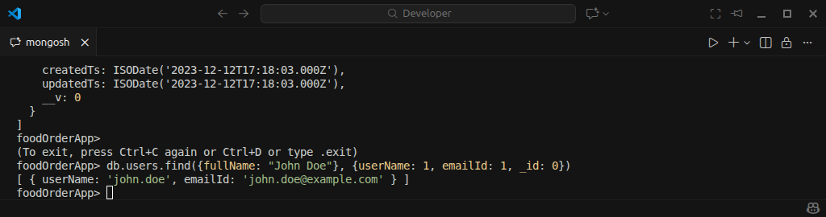

- Retrieve details of the order with the lowest orderTotalPrice.

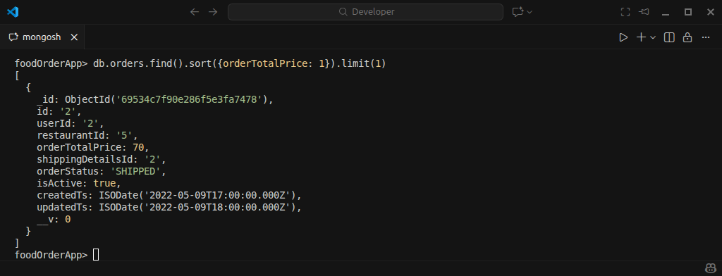

- Get the count of menu items for fooditem “Veg Pizza”.

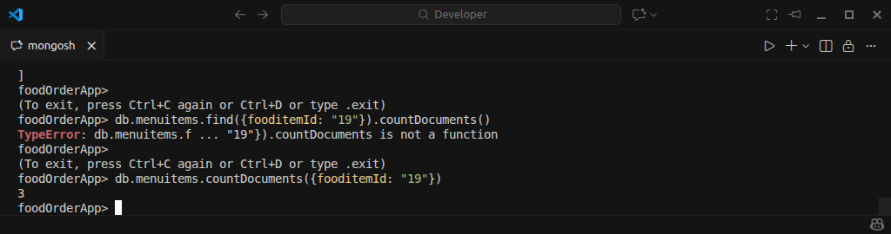

- Get the count of orders for each restaurant.

